MULTI DIMENSIONAL BI REPORTING FOR CUSTOMER SEGMENTION ANALYSIS

A PROJCT REPORT

Submitted by

GOKULA LAKSHMI R
HARINI VK
KESHIYA C
MADUSHKA K

in partial fulfilment for the award of the degree
of

ADI1231 BUSINESS INTELLIGENCE

BACHELOR OF TECHNOLOGY
IN
DEPARTMENT OF

ARTIFICIAL INTELLIGENCE AND DATA SCIENCE


K. RAMAKRISHNAN COLLEGE OF ENGINEERING (AUTONOMOUS)
SAMAYAPURAM, TRICHY

ANNA UNIVERSITY

CHENNAI 600 025

MAY 2026
MULTI DIMENSIONAL BI REPORTING FOR CUSTOMER SEGMENTION ANALYSIS

ADI1231 BUSINESS INTELLIGENCE

Submitted by

GOKULA LAKSHMI R  HARINI VK  KESHIYA C  MADUSHKA K | (8115U24AD033)  (8115U24AD035)  (8115U24AD048)  (8115U24AD055)

in partial fulfilment for the award of the degree

of
ADI1231 BUSINESS INTELLIGENCE

BACHELOR OF TECHNOLOGY
IN
DEPARTMENT OF
ARTIFICIAL INTELLIGENCE AND DATA SCIENCE

Under the Guidance of Mr. MOHAMED FAIZAL M K
DEPARTMENT OF ARTIFICIAL INTELLIGENCE AND DATA SCIENCE
K. RAMAKRISHNAN COLLEGE OF ENGINEERING (AUTONOMOUS)
Under
ANNA UNIVERSITY, CHENNAI

K. RAMAKRISHNAN COLLEGE OF ENGINEERING (AUTONOMOUS)
Under
ANNA UNIVERSITY, CHENNAI

BONAFIDE CERTIFICATE

Certified that it report titled “MULTI DIMENSIONAL BI REPORTING FOR CUSTOMER SEGMENTION ANALYSIS” is the bonafide work of GOKULA LAKSHMI (8115U24AD033), HARINI VK (8115U24AD035), KESHIYA C (8115U24AD048), MADUSHKA K (8115U24AD055) who carried out the work under my supervision.

Dr. B.KIRAN BALA, M.E., Ph.D., | Mrs. M.K.MOHAMED FAIZAL, M.E.,Ph.D.
HEAD OF THE DEPARTMENT, | SUPERVISOR,
Department of Artificial Intelligence  and Data Science, | Department of Artificial Intelligence  and Data Science,
K. Ramakrishnan College of Engineering, | K. Ramakrishnan College of Engineering,
Samayapuram, Trichy-621 112.  . | Samayapuram, Trichy-621 112.

SIGNATURE : SIGNATURE :
NAME: NAME:
DATE: DATE:

K. RAMAKRISHNAN COLLEGE OF ENGINEERING
(AUTONOMOUS)
Under
ANNA UNIVERSITY, CHENNAI
DECLARATION BY THE CANDIDATES
We declare that, to the best of our knowledge, the work reported here has been composed solely by us and has not been submitted, either in whole or in part, for any previous application for a course

Submitted for the project Viva- Voce held at K. Ramakrishnan College of Engineering on
.

SIGNATURE OF THE CANDIDATES

ACKNOWLEDGEMENT

We thank the almighty GOD, without whom it would not have been possible for us to complete our project.

I extend our sincere acknowledgment and appreciation to the esteemed and honourable Chairman, Dr. K. RAMAKRISHNAN, B.E., for having provided the facilities during the course of our study in college.

We extend our hearty gratitude and thanks to our honorable and grateful Executive Director Dr.S.KUPPUSAMY, B.Sc.,MBA., Ph.D., K. Ramakrishnan College of Engineering(Autonomous).

We are glad to thank our Principal Dr.D.SRINIVASAN, M.E., Ph.D., FIE., MIIW., MISTE., MISAE., C.Engg, for giving us permission to carry out it.

We wish to convey our sincere thanks to Dr.B.KIRAN BALA, B.Tech., M.E., M.B.A., Ph.D., Head of the Department, Artificial Intelligence and Data Science for giving us constant encouragement and advice throughout the course.

We are grateful to M.K.MOHAMED FAIZAL, M.E.,Ph.D, Artificial Intelligence and Data Science, K. Ramakrishnan College of Engineering (Autonomous), for his guidance and valuable suggestions during the course of study.

Finally, we sincerely acknowledged in no less terms all our staff members, our parents and, friends for their co-operation and help at various stages of it work.

GOKULA LAKSHMI R  HARINI VK  KESHIYA C  MADUSHKA K | (8115U24AD033)  (8115U24AD035)  (8115U24AD048)  (8115U24AD055)

DEPARTMENT OF ARTIFICIAL INTELLIGENCE AND DATA SCIENCE
VISION
To excel in education, innovation, and research in Artificial Intelligence and Data Science to fulfil industrial demands and societal expectations.
MISSION
Mission of the Department
M1 To educate future engineers with solid fundamentals, continually improving teaching methods using modern tools.
M2 To collaborate with industry and offer top-notch facilities in a conducive learning environment.
M3 To foster skilled engineers and ethical innovation in AI and Data Science for global recognition and impactful research.
M4 To tackle the societal challenge of producing capable professionals by instilling employability skills and human values.

PROGRAM EDUCATIONAL OBJECTIVES (PEO’s)

PEO1 Compete on a global scale for a professional career in Artificial Intelligence and Data Science.
PEO2 Provide industry-specific solutions for the society with effective communication and ethics.
PEO3 Enhance their professional skills through research and lifelong learning initiatives.

PROGRAM SPECIFIC OUTCOMES (PSO’s)

PSO1 Capable of finding the important factors in large datasets, simplify the data, and improve predictive model accuracy.
PSO2 Capable of analyzing and providing a solution to a given real-world problem by designing an effective program.
.

PROGRAM OUTCOMES
Engineering students will be able to:
- Engineering knowledge: Apply the knowledge of mathematics, science, engineering fundamentals, and an engineering specialization to the solution of complex engineering problems.
- Problem analysis: Identify, formulate, review research literature, and analyze complex engineering problems reaching substantiated conclusions using first principles of mathematics, natural sciences, and engineering sciences.
- Design/development of solutions: Design solutions for complex engineering problems and design system components or processes that meet the specified needs with appropriate consideration for the public health and safety, and the cultural, societal, and environmental considerations.
- Conduct investigations of complex problems: Use research-based knowledge and research methods including design of experiments, analysis and interpretation of data, and synthesis of the information to provide valid conclusions.
- Modern tool usage: Create, select, and apply appropriate techniques, resources, and modern engineering and IT tools including prediction and modeling to complex engineering activities with an understanding of the limitations.
- The engineer and society: Apply reasoning informed by the contextual knowledge to assess societal, health, safety, legal and cultural issues and the consequent responsibilities relevant to the professional engineering practice.
- Environment and sustainability: Understand the impact of the professional engineering solutions in societal and environmental contexts, and demonstrate the knowledge of, and need for sustainable development.
- Ethics: Apply ethical principles and commit to professional ethics and responsibilities and norms of the engineering practice.
- Individual and team work: Function effectively as an individual, and as a member or leader in diverse teams, and in multidisciplinary settings.
- Communication: Communicate effectively on complex engineering activities with the engineering community and with society at large, such as, being able to comprehend and write effective reports and design documentation, make effective presentations, and give and receive clear instructions.

- Project management and finance: Demonstrate knowledge and understanding of the engineering and management principles and apply these to one’s own work, as a member and leader in a team, to manage projects and in multidisciplinary environments.
- Life-long learning: Recognize the need for, and have the preparation and ability to engage in independent and life-long learning in the broadest context of technological change.

PROGRAM SPECIFIC OUTCOMES (PSOs)
  - PSO1: To develop optimized Data Science Solutions, through analysis, design, implementation, and evaluation to give technological solutions for real-time societal issues.
  - PSO2: To employ advanced analytic platforms in creating innovative career paths to become best data scientists.

ABSTRACT

In the era of digital transformation, data-driven decision-making has become essential in the banking sector, particularly in managing financial risks. This report presents a comprehensive approach to predicting loan defaults using Business Intelligence (BI) tools and interactive dashboards. By integrating data from multiple sources such as Excel files, SQL databases, and financial records, the system enables stakeholders to analyze borrower behavior and identify potential risk patterns across various dimensions including time, geography, loan type, and customer profiles. The dashboard is designed for usability, real-time monitoring, and actionable insights, supporting banks in making informed lending decisions. Advanced data cleaning, transformation, and modeling techniques are applied to ensure accuracy and reliability. Key visualizations such as line charts, bar graphs, pie charts, and heatmaps are used to simplify complex financial data and highlight critical trends. Important metrics and Key Performance Indicators (KPIs), including default rate, loan approval rate, credit risk score, and recovery rate, are calculated using DAX to provide a deeper understanding of loan performance. By analyzing historical data, identifying high-risk customers, and enabling predictive insights, this project serves as a valuable analytical tool for minimizing financial losses.
This data-driven approach enhances operational efficiency, improves risk management strategies, and supports strategic planning in the banking sector. The report concludes with dashboard screenshots and DAX code snippets, making it a useful reference for both technical developers and financial decision-makers.

TABLE OF CONTENT

CHAPTER  No. | TITLE | PAGE  No.
 | ABSTRACT | ix
 | LIST OF FIGURE | x
 | LIST OF ABBREVIATION | xi
1 | INTRODUCTION | 1
 | 1.1 Project Overview | 1
 | 1.2 Objective | 3
 | 1.3 Goals | 4
 | 1.4 Scope of the Dashboard | 4
2 | DATA SOURCES | 6
 | 2.1 Data Collection Methods | 6
 | 2.2 Data Cleaning & Transformation Steps | 8
3 | DASHBOARD DESIGN | 11
 | 3.1 Layout & Structure | 11
 | 3.2 Key Metrics & KPIs | 14
 | 3.3 Visualizations Used | 16
4 | ANALYSIS & INSIGHTS | 18
 | 4.1 Trends & Patterns | 18
 | 4.2 Comparisons | 20
 | 4.3 Benchmarks | 22
5 | DATA MODELING | 24
 | 5.1 Relationships Between Tables | 24

 | 5.2 Measures and Calculated Columns | 26
 | 5.3 Use of Power BI | 28
6 | APPENDIX | 30
 | 6.1 Screenshots of Dashboard Pages | 30
 | 6.2 DAX Functions | 34

LIST OF FIGURES

FIGURE NO | FIGURE NAME | PAGE NO
A.1 | Home Page | 24
A.2 | Product Analysis | 24
A.3 | Graphic Analysis | 25

LIST OF ABBREVIATIONS

DAX | Data Analysis Expressions
KPI | Key Performance Indicator
SQL | Structured Query Language
API | Application Program Interface
BI | Business Intelligence
AOV | Average Order Value
YoY | Year-over-Year
YTD | Year-To-Date
CSV | Comma Seperated Value
ETL | Extract, Transform, Load
UX | User Experience
UI | User Interface
DBMS | Database Management System
ROI | Return On Investment
SKU | Stock Keeping Unit
JSON | JavaScript Object Notation
Excel | Microsoft Excel
RDBMS | Relational Database Management System
SQL Server | Structured Query Language Server
AI | Artificial Intelligence
ML | Machine Learning
OLAP | Online Analytical Processing

CHAPTER 1

INTRODUCTION

In the modern banking environment, managing financial risk has become increasingly complex due to the rapid growth of digital transactions and large volumes of customer data. One of the most critical challenges faced by financial institutions is loan default, where borrowers fail to repay their loans on time. Loan defaults not only result in financial losses but also affect the stability and profitability of banks. Therefore, predicting potential defaulters in advance has become essential for effective risk management and decision-making.

1.1 PROJECT OVERVIEW:
The Sales Analysis Dashboard project is developed to provide a comprehensive and interactive platform for analyzing business performance using modern data visualization techniques. In today’s competitive business environment, organizations generate vast amounts of data, and it becomes essential to convert this raw data into meaningful insights. This project focuses on transforming structured sales data into an easy-to-understand visual format using Power BI.

The dashboard integrates multiple aspects of business operations, including sales, profit, shipping costs, customer segmentation, product categories, and geographic distribution. By combining these elements into a unified system, the dashboard allows users to explore different dimensions of business performance without the need for complex manual calculations. It simplifies the decision-making process by presenting key information visually.
The project is structured into three main analytical sections: Sales Overview, Product Analysis, and Geographic Analysis. Each section highlights specific insights .This structured approach ensures that users can navigate through the data efficiently and gain a complete understanding of business trends.

Overall, the dashboard serves as a powerful analytical tool that helps businesses monitor performance, identify trends, and uncover opportunities for improvement. It demonstrates how data visualization can be used effectively to enhance business intelligence and support strategic planning.

1.2 OBJECTIVE:
The primary objective of this project is to analyze sales data and generate meaningful insights that can assist in effective business decision-making. The dashboard is designed to present complex datasets in a simplified and visually appealing format, making it easier for users to interpret information and identify patterns.

One of the key objectives is to evaluate the overall business performance by analyzing important metrics such as total sales, profit, and shipping costs. These metrics provide a clear picture of how the business is performing financially and help in identifying areas where improvements are needed. Understanding these indicators is crucial for maintaining profitability and operational efficiency.

Another important objective is to study sales trends over time. By analyzing monthly sales data, the project aims to identify seasonal variations and patterns that influence customer purchasing behavior. This helps businesses plan marketing strategies, manage inventory, and prepare for high-demand periods effectively.

In addition, the project aims to compare performance across different customer segments, product categories, and geographic regions. This comparative analysis helps in identifying high-performing areas and areas that require attention.
1.3 GOALS

The goal of this project is to develop a highly interactive and user-friendly dashboard that enables efficient data analysis and visualization. The dashboard is designed to cater to business users who need quick and accurate insights without requiring technical expertise in data analysis.

One of the major goals is to enhance data visibility by presenting key performance indicators in a clear and concise manner. By using visual elements such as charts, graphs, and maps, the dashboard ensures that users can easily understand complex data relationships and trends. This improves overall data comprehension and accessibility.

Another important goal is to identify business opportunities and challenges. By analyzing sales patterns, product performance, and regional distribution, the dashboard helps in recognizing areas of growth as well as areas that need improvement. This enables businesses to take proactive measures and optimize their operations.

Furthermore, the project aims to support strategic decision-making by providing reliable and real-time insights. The dashboard acts as a decision-support system that helps managers and stakeholders make informed choices based on data. It also encourages a data-driven culture within the organization. the dashboard ensures that users can easily understand complex data relationships By using visual elements such as charts, graphs, and maps, the dashboard ensures that users can easily understand complex data relationships and trends. This improves overall data comprehension and accessibility. One of the major goals is to enhance data visibility by presenting key performance indicators in a clear and concise manner. By using visual elements such as charts, graphs, and maps, the dashboard ensures that users can easily understand complex data relationships and trends. This improves overall data comprehension and accessibilit
1.4 SCOPE OF THE PROJECT:

The scope of this dashboard is focused on analyzing historical sales data and presenting it in a structured and meaningful way. It covers various aspects of business performance, including time-based analysis, customer segmentation, product performance, and geographic distribution.

The dashboard includes detailed analysis of monthly sales trends, allowing users to understand how sales vary throughout the year. It also provides insights into customer segments such as Consumer, Corporate, and Home Office, helping businesses identify their target audience and key revenue contributors.

In addition, the dashboard analyzes product categories and sub-categories to determine which products generate the most revenue. This information is useful for inventory management, product development, and marketing strategies. The geographic analysis further extends the scope by providing insights into sales performance across different countries and regions.

However, it is important to note that the scope of this project is limited to descriptive analytics. It does not include predictive modeling or forecasting. The dashboard focuses on analyzing past and present data to generate insights rather than predicting future outcomes. The scope of this dashboard is focused on analyzing historical sales data and presenting it in a structured and meaningful way. It covers various aspects of business performance, including time-based analysis, customer segmentation, product performance, and geographic distribution The geographic analysis further extends the scope by providing insights into sales performance across different countries and regions

CHAPTER 2
DATA SOURCES

The data used in this project is collected from multiple sources to ensure comprehensive analysis and accurate prediction of loan defaults. The primary source of data includes structured databases such as SQL, where detailed information about customers, loan applications, repayment history, and credit scores is stored. These databases provide reliable and organized data that forms the foundation of the project. Secondary data sources include Excel files and CSV datasets, which contain historical loan records and financial details maintained by banking institutions.

2.1 DATA COLLECTION METHODS
The data used in this project is collected from a structured dataset that contains detailed information about sales transactions. This dataset includes various attributes such as order date, sales amount, profit, shipping cost, customer segment, product category, and geographic location.

The data collection process involves gathering relevant fields that are essential for analysis. These fields are selected based on the objectives of the project and the type of insights required. By including multiple dimensions such as time, customer, product, and location, the dataset provides a comprehensive view of business operations.

The dataset is assumed to be sourced from a reliable system such as a retail management system or an enterprise database. It represents real-world business scenarios and is suitable for performing analytical operations. The structured format of the data makes it easy to process and analyze using Power BI.

Overall, the data collection process ensures that all necessary information is available for building the dashboard. The quality and completeness of the data play a crucial role in determining the accuracy of the insights generated.

2.2 DATA CLEANING AND TRANSFORMATION STEPS

Before building the dashboard, the dataset undergoes a series of data cleaning and transformation steps to ensure accuracy and consistency. Data preprocessing is an essential step in any data analysis project, as it eliminates errors and prepares the data for meaningful analysis.

The first step involves removing duplicate records to avoid redundancy and ensure that each transaction is unique. Next, missing or null values are identified and handled appropriately, either by filling them with suitable values or removing incomplete records. This helps maintain data integrity and reliability.

Another important step is the transformation of data types. Date fields are converted into proper date formats to enable time-based analysis. Additional columns such as Month and Year are created from the order date to facilitate monthly trend analysis. Similarly, categorical fields are standardized to ensure consistency across the dataset.
Finally, calculated columns and measures are created to derive additional insights. These transformations enhance the dataset and make it suitable for visualization. Proper data cleaning and transformation ensure that the dashboard provides accurate and meaningful results.

Data cleaning and transformation involve preparing raw data for analysis by improving its quality and consistency. This includes handling missing values, removing duplicate records, and correcting data formats. Irrelevant data is filtered out, and inconsistencies
CHAPTER 3
DASHBOARD DESIGN

The dashboard design plays a crucial role in this project by providing a clear and interactive platform to visualize and analyze loan default data. It is developed using Business Intelligence (BI) tools such as Power BI, ensuring a user-friendly interface that allows stakeholders to easily understand complex financial information. The dashboard is structured to present key insights through well-organized layouts, enabling quick access to important metrics and trends.

3.1 LAYOUT AND STRUCTURE
The customer demographics section presents data related to applicants’ age, gender, and
employment type through visual charts. This analysis helps in identifying which groups are more likely to default on loans. Understanding demographic patterns enables banks to tailor their lending strategies and policies to specific customer segments.

Sales Overview Section
The Sales Overview section provides a high-level summary of the overall business performance through key metrics and visual indicators. This section includes important KPIs such as total sales, total profit, and shipping cost, which are displayed prominently using card visuals. These indicators give users a quick understanding of the financial status of the business without requiring deep analysis.

In addition to KPI cards, this section includes a monthly sales trend chart that visually represents how sales fluctuate over time. By analyzing this trend, users can identify patterns such as peak sales periods and low-performing months. The visual clearly

shows a gradual increase in sales towards the end of the year, indicating seasonal demand and business growth.

Another important component of this section is the segment-wise sales comparison. The bar chart displays how different customer segments, such as Consumer, Corporate, and Home Office, contribute to total sales. This comparison helps in identifying the most valuable customer group and understanding where the majority of revenue is generated.

Overall, the Sales Overview section acts as the foundation of the dashboard by providing a comprehensive snapshot of performance. It enables users to quickly assess business health and identify key areas for further analysis.

Product Analysis Section
The Product Analysis section focuses on understanding the performance of different product categories and sub-categories. It uses a treemap visualization to represent the contribution of each product category to total sales. Larger blocks in the treemap indicate higher sales contribution, making it easy to identify top-performing products.

This section highlights that categories such as phones, chairs, and bookcases generate the highest revenue, while smaller categories like supplies and envelopes contribute less. This information is valuable for inventory management, marketing strategies, and product development decisions.

In addition to sales distribution, this section also includes a quantity analysis by customer segment using a donut chart. This visualization shows how different segments contribute to the total quantity sold, providing insights into customer purchasing behavior and demand patterns

Furthermore, the section includes an average order value indicator, which helps in
understanding the purchasing capacity of customers. By analyzing this metric,
businesses can evaluate how much revenue is generated per transaction and identify opportunities to increase sales value.

Geographic Analysis Section
The Geographic Analysis section provides insights into sales performance across different countries and regions. It includes a map visualization that displays the sales of
distribution of sales worldwide, allowing users to quickly identify high-performing regions.

This section also features a bar chart that compares sales across various countries. The chart clearly shows that the United States contributes the highest sales, followed by countries such as Australia, France, and China. This comparison helps in identifying key markets and regions with strong business presence.

In addition to sales, this section includes a profit analysis by region. The profit chart highlights how different regions contribute to overall profitability, revealing that some regions generate high sales but lower profits. This indicates potential issues such as high costs or inefficiencies.

Overall, the Geographic Analysis section helps businesses understand their global performance and identify opportunities for expansion or improvement in specific regions.

Sales Trend Analysis
The Sales Trend Analysis component focuses on identifying patterns and variations in sales over time. The line chart represents monthly sales data, making it easier to observe
The analysis shows that sales start at a lower level in the beginning of the year and gradually increase over time. A slight decline is observed during the mid-year period, followed by a significant rise towards the end of the year. This indicates the presence of seasonal demand, possibly influenced by festive seasons or promotional activities.
By studying these trends, businesses can plan their operations more effectively. For example, they can increase inventory and marketing efforts during peak months while optimizing costs during low-demand periods.

Customer Segment Analysis
The Customer Segment Analysis section examines how different groups of customers contribute to overall sales and quantity. It categorizes customers into Consumer, Corporate, and Home Office segments and analyzes their performance using bar and donut charts.

The analysis reveals that the Consumer segment is the dominant contributor in terms of both sales and quantity. This indicates that individual customers play a major role in driving business revenue. The Corporate segment follows, while the Home Office segment contributes the least.

Understanding customer segmentation helps businesses tailor their strategies according to different customer groups. For example, marketing campaigns can be designed specifically for high-value segments to maximize returns.
This section provides valuable insights into customer behavior and helps in improving customer targeting and engagement strategies.

Interactive Navigation and Filters
The dashboard includes interactive navigation features that enhance user experience and usability. Navigation buttons are provided to switch between different sections .
These interactive elements allow users to explore the dashboard in a structured manner without confusion. Users can easily move between pages and access different types of analysis based on their requirements.

Although not heavily filter-based, the dashboard design supports interactive exploration through visual elements. Users can interpret data dynamically by observing relationships between different charts and visuals.

Overall, the interactive design ensures that the dashboard is user-friendly and accessible, making it suitable for both technical and non-technical users.

3.2 KEY METRICS AND KPIS:
Key Performance Indicators (KPIs) are an essential part of the dashboard, as they provide a quick overview of business performance. These metrics are displayed prominently using card visuals, making them easily visible to users.

The main KPIs in the dashboard include Total Sales, Total Profit, and Shipping Cost. These metrics help in understanding the financial performance of the business. For example, total sales indicate revenue generation, while profit reflects the overall earnings after expenses.

In addition to these primary metrics, other indicators such as quantity and average order value are also included. These metrics provide deeper insights into customer purchasing behavior and transaction patterns. Together, these KPIs form the foundation of the dashboard.

The use of KPIs allows users to quickly assess the performance of the business without going into detailed analysis. They serve as a starting point for further
3.3 VISUALIZATIONS USED
Visualizations play a crucial role in transforming complex loan data into meaningful and easy-to-understand insights. In this project, various charts and graphical representations are used to analyze loan performance, customer behavior, and default risks. These visual tools help decision-makers quickly identify patterns, trends, and high-risk areas, improving the efficiency of data-driven decisions.

Heatmaps
Heatmaps are used to represent data intensity using colors. They are useful for identifying high-risk areas or customer segments by highlighting patterns in large datasets. Darker colors typically indicate higher risk or values.

Tables and KPI Cards
Tables and KPI cards are used to display exact numerical values such as total loans, default rate, and average income. KPI cards provide quick insights at a glance, while tables offer detailed information for deeper analysis.

Filters and Slicers
Filters and slicers are interactive visualization tools that allow users to customize the dashboard view. Users can filter data based on criteria like age, income, loan type, or region, making the analysis more flexible and user-friendly.

Line Chart
The line chart is used to represent sales trends over time, specifically month-wise
sales performance. It helps in identifying patterns such as growth, decline, an.
This visualization is very effective for time-based data because it shows how values change continuously. In your dashboard, it clearly highlights peak sales months and low-performing periods.

Bar Chart
Bar charts are used to compare values across different categories such as customer segments and countries. They make it easy to identify which category performs better.
In your dashboard, bar charts show:
- Sales by Customer Segment
- Sales by Country
This helps in comparing performance and identifying the highest and lowest.

Donut Chart
The donut chart is used to show the percentage distribution of quantity across different segments. It provides a clear view of how each segment contributes to the total.
This visualization is useful for understanding proportions and relative contributions. In your dashboard, it shows how much each customer segment contributes in terms of quantity.

Map Visualization
The map visualization is used to display sales distribution across different countries and regions. It provides a geographic perspective of business performance.
This helps in identifying high-performing regions and potential markets. The map makes it easier to understand location-based data visually.

CHAPTER 4
ANALYSIS AND INSIGHTS

The analysis and insights section focuses on interpreting the data collected from loan applications to identify patterns, trends, and risk factors associated with loan defaults. By using BI tools, the raw data is transformed into meaningful information that supports decision-making. This section helps banks understand customer behavior, evaluate financial risk, and improve lending strategies.

4.1 TREANDS AND PATTERNS
The trends and patterns section focuses on identifying recurring behaviors and changes in loan data over time. By analyzing historical data using BI tools, banks can detect patterns in loan approvals, repayments, and defaults. Understanding these trends helps in predicting future risks and improving decision-making strategies.

1. Loan Default Trends
- Shows changes in default rates over time
- Identifies increase, decrease, or stability in defaults
- Helps banks take preventive actions

2. Customer Behavior Patterns
- Analyzes repayment habits of customers
- Identifies reliable and risky borrowers
- Shows impact of income stability on repayment

3. Income and Credit Score Patterns
- Shows relationship between income, credit score, and default
- High income + good credit score = low risk
- Low income + poor credit score = high risk

4. Loan Type Trends
- Compares default rates across loan types
- Identifies high-risk loan categories
- Helps in improving loan approval policies

5. Seasonal and Time-Based Trends
- Shows variation in loans during different time periods
- Identifies peak loan demand seasons
- Helps in planning banking operations

6. Key Insights from Trends
- Helps in identifying risk patterns
- Supports better decision-making
- Improves risk management strategies
- Assists in policy planning

The Trends and Patterns section focuses on identifying how sales performance changes over time and across different dimensions. By analyzing the monthly sales trend line chart, it becomes evident that the business experiences fluctuations throughout the year. Sales begin at a relatively lower level during the initial months, particularly in January and February, indicating a slower start to the business cycle.
As the months progress, a steady increase in sales can be observed from March to

June. This growth suggests an improvement in customer demand and possibly the impact of marketing efforts or seasonal buying behavior. However, a slight decline is

Noticed during the mid-year period, especially around July, which may indicate a temporary slowdown in business activity.
A significant rise in sales is observed from August onwards, reaching peak levels in November and December. This pattern clearly indicates the presence of seasonal demand, likely driven by festivals, holidays, and promotional campaigns. The year-end surge in sales highlights the importance of strategic planning during peak seasons.
Overall, the trend analysis helps businesses understand the cyclical nature of sales and prepare accordingly. By identifying high-performing and low-performing periods, organizations can optimize inventory, marketing strategies, and resource allocation to maximize revenue.

4.2 COMPARISONS

The Comparisons section provides a detailed evaluation of performance across different categories such as customer segments, product categories, and geographic regions. By comparing these dimensions, the dashboard highlights which areas contribute the most to overall business success.

In terms of customer segments, the Consumer segment stands out as the highest contributor to total sales, followed by the Corporate segment and then the Home Office segment. This comparison indicates that individual customers play a major role in revenue generation, making them a key focus area for marketing and customer engagement strategies.

When analyzing product categories, it is evident that certain products such as phones, chairs, and bookcases generate significantly higher sales compared to others. On the other hand,

categories like supplies and envelopes show relatively lower performance. This comparison helps businesses identify which products are driving revenue and which ones require improvement.
Geographic comparison further reveals that the United States is the leading contributor to sales, followed by countries like Australia, France, and China. Some countries show lower sales, indicating potential markets for expansion. Overall, comparative analysis enables businesses to identify strengths and weaknesses across different dimensions.

4.3 BENCHMARKS

The Benchmarks section establishes performance standards based on the data analyzed in the dashboard. These benchmarks serve as reference points that help businesses evaluate their current performance and set future targets.

One of the key benchmarks identified is the Consumer segment, which consistently contributes the highest sales and quantity. This segment can be considered the standard for evaluating other segments. Similarly, the months of November and December serve as benchmarks for peak sales performance due to their high revenue generation
.
In terms of product performance, categories such as phones and chairs set the benchmark for high sales contribution. These products can be used as a reference for evaluating the performance of other categories. Businesses can analyze what makes these products successful and apply similar strategies to other products.
CHAPTER 5
DATA MODELING

As the months progress, a steady increase in sales can be observed from March to June. This growth suggests an improvement in customer demand and possibly the impact of marketing efforts or seasonal buying behavior. However, a slight decline is noticed during the mid-year period, especially around July, which may indicate a temporary slowdown in business activity.

A significant rise in sales is observed from August onwards, reaching peak levels in November and December. This pattern clearly indicates the presence of seasonal demand, likely driven by festivals, holidays, and promotional campaigns. The year-end surge in sales highlights the importance of strategic planning during peak seasons.

Overall, the trend analysis helps businesses understand the cyclical nature of sales and prepare accordingly. By identifying high-performing and low-performing periods, organizations can optimize inventory, marketing strategies, and resource allocation to maximize revenue.

5.1 TRENDS & PATTERNS
The Trends and Patterns section focuses on identifying how sales performance changes over time and across different dimensions. By analyzing the monthly sales trend line chart, it becomes evident that the business experiences fluctuations throughout the year. Sales begin at a relatively lower level during the initial months, particularly in January and February, indicating a slower start to the business cycle.As the months progress, a steady increase in sales can be observed from March to June.
This growth suggests an improvement in customer demand and possibly the impact of
marketing efforts or seasonal buying behavior. However, a slight decline is noticed during the mid-year period, especially around July, which may indicate a temporary slowdown in business activity.

A significant rise in sales is observed from August onwards, reaching peak levels in November and December. This pattern clearly indicates the presence of seasonal demand, likely driven by festivals, holidays, and promotional campaigns. The year-end surge in sales highlights the importance of strategic planning during peak seasons.

Overall, the trend analysis helps businesses understand the cyclical nature of sales and prepare accordingly. By identifying high-performing and low-performing periods, organizations can optimize inventory, marketing strategies, and resource allocation to maximize revenue

5.2 COMPARISONS
The Comparisons section provides a detailed evaluation of performance across different categories such as customer segments, product categories, and geographic regions. By comparing these dimensions, the dashboard highlights which areas contribute the most to overall business success.

In terms of customer segments, the Consumer segment stands out as the highest contributor to total sales, followed by the Corporate segment and then the Home Office segment. This comparison indicates that individual customers play a major role in revenue generation, making them a key focus area for marketing and customer engagement strategies.

When analyzing product categories, it is evident that certain products such as phones, chairs, and bookcases generate significantly higher sales compared to others. On the other
hand, categories like supplies and envelopes show relatively lower performance. This comparison helps businesses identify which products are driving revenue and which ones require improvement.

Geographic comparison further reveals that the United States is the leading contributor to sales, followed by countries like Australia, France, and China. Some countries show lower
sales, indicating potential markets for expansion. Overall, comparative analysis enables businesses to identify strengths and weaknesses across different dimensions.

5.3 BENCHMARKS

The Benchmarks section establishes performance standards based on the data analyzed in the dashboard. These benchmarks serve as reference points that help businesses evaluate their current performance and set future targets.

One of the key benchmarks identified is the Consumer segment, which consistently contributes the highest sales and quantity. This segment can be considered the standard for evaluating other segments. Similarly, the months of November and December serve as benchmarks for peak sales performance due to their high revenue generation.

In terms of product performance, categories such as phones and chairs set the benchmark for high sales contribution. These products can be used as a reference for evaluating the performance of other categories. Businesses can analyze what mak
CHAPTER 6
APPENDIX

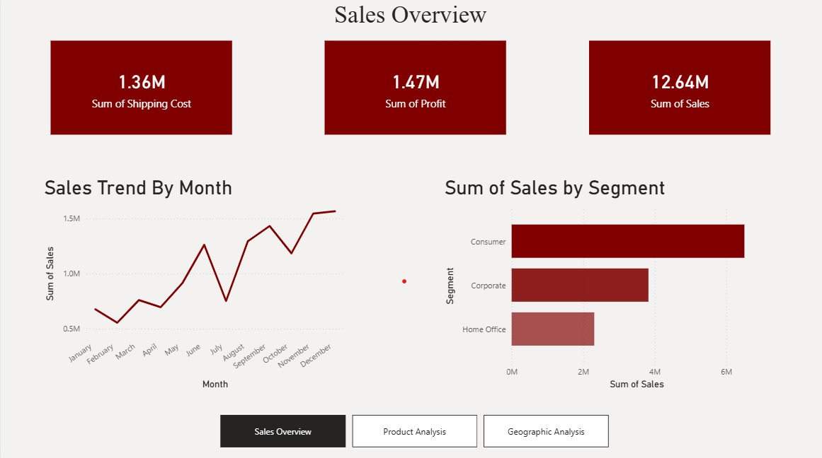
Figure A.1 Home Page

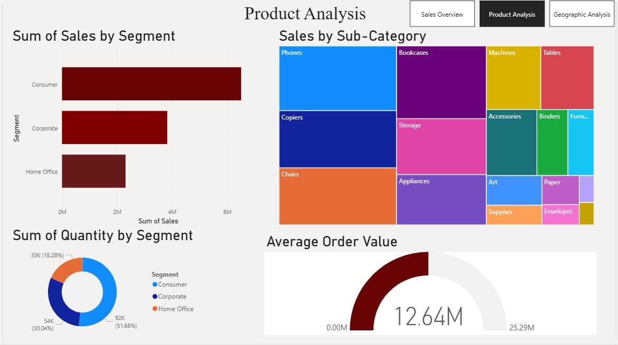

Figure A.2 Product Analysis

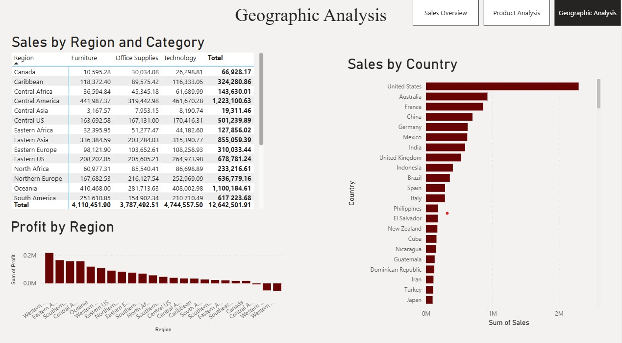

Figure A.3 Graphic Analysis

DAX FUNCTIONS:

Data Analysis Expressions (DAX) is a formula language used in Power BI to perform calculations and create custom measures and columns. In this Sales Analysis Dashboard, DAX functions play a crucial role in transforming raw data into meaningful insights. They are used to calculate key performance indicators such as total sales, profit, shipping cost, and quantity.

DAX functions are dynamic in nature, meaning the results change automatically based on filters and user interactions in the dashboard. This makes them highly effective for building interactive reports. Without DAX, it would not be possible to perform advanced calculations or create customized metrics required for analysis.

The use of DAX in this dashboard ensures accuracy, flexibility, and efficiency in data analysis. It allows the creation of reusable formulas that can be applied across multiple visualizations. This improves consistency and reduces manual effort in calculations.Overall, DAX functions enhance the analytical capabilities of the dashboard and support the generation of real-time insights.

Total Sales:
The Total Sales measure is used to calculate the overall revenue generated from all transactions. It is one of the most important metrics in the dashboard and is displayed using a KPI card.
This measure aggregates the sales values from the dataset and provides a single value representing total business performance. It is also used in various visualizations such as line charts and bar charts.
DAX Formula:
Total Sales = SUM(Sales[Sales])
This function sums up all the sales values in the Sales column, giving the total revenue.

Total Profit:
The Total Profit measure calculates the net profit earned by the business after deducting costs. It helps in understanding the profitability of operations
This measure is essential for evaluating financial performance and is displayed alongside total sales in the dashboard. It also helps in identifying whether the business is generating sufficient returns.
DAX Formula:
Total Profit = SUM(Sales[Profit])
This function aggregates all profit values from the dataset.

Sales by Segment:
This measure helps in calculating sales for each customer segment such as Consumer, Corporate, and Home Office. It is used in bar charts for comparison.
It allows businesses to identify which segment contributes the most to revenue.
DAX Formula :
Sales by Segment = SUM(Sales[Sales])
This measure works with filters applied on the segment field.

Monthly Sales:
Monthly Sales is used to analyze sales performance over time. It helps in identifying trends and seasonal patterns.
This measure works with the Month column derived from the Order Date.
DAX Formula:
Monthly Sales = CALCULATE(SUM(Sales[Sales]))

